**Annexure 1**

Project Report

on

**Content Writing & Marketing Internship at Kshitiksha Foundation**

Submitted

In Partial Fulfillment of

**Bsc IT**

**Submitted by:**



Name: BEAUTY RANI

(Roll No): 24/SCA/BscIT/014

**Under the Supervision of:**

(Project Report Preparation Guidelines)



**School of Computer Applications**

**Manav Rachna International Institute of Research and Studies**

**(DEEMED TO BE UNIVERSITY)**

Sector-43, Aravalli Hills

Faridabad – 121001

**June 2025**

**Annexure 2**

**Declaration**

I do hereby declare that this project work entitled “**Content Writing & Marketing Internship at Kshitiksha Foundation** ” submitted by me for the partial fulfillment of the requirement for the award of **BACHELOR OF SCIENCE IN INFORMATION TECHNOLOGY** is a record of my own work. The report embodies the finding based on my study and observation and has not been submitted earlier for the award of any degree or diploma to any Institute or University.

**SIGNATURE**

Name: Beauty Rani.

Roll No: 24/SCA/BscIT/014

Date: 02/08/2025

**Annexure 3**

**Certificate from the Guide**

This is to certify that the project report entitled “_____________­­­­­____________________________” submitted in partial fulfillment of the degree of **BACHELOR OF SCIENCE IN INFORMATION TECHNOLOGY** to Manav Rachna International Institute of Research and Studies, Faridabad is carried out by Mr./ Ms.______________(Roll No), _______________ under my guidance.

**Signature of the Guide**

Name:

Date:

**Head of Department**

Name:

Date:

**ACKNOWLEDGEMENT**

I gratefully acknowledge for the assistance, cooperation, guidance and clarification provided by Ms./Mr. ______________ during the development of ______________. My extreme gratitude to **Dr. Raj Kumar, Associate Professor & TPO** who guided us throughout the project. Without his willing disposition, spirit accommodation, frankness, timely clarification and above all faith in us, this project could not have been completed in due time. His readiness to discuss all important matters at work deserves special attention of.

I would like to extend my sincere gratitude to **Prof. (Dr.) Suhail Javed Quraishi – HOD, Prof. (Dr.) Rashmi Agrawal – Associate Dean and Prof. (Dr.) Brijesh Kumar – Dean** for their valuable teachings and advice. I want to thank all the department faculty members for their cooperation and support. I want to thank non-teaching staff of the department for their cooperation and support.

This opportunity is a big milestone in my career development. I will strive to use gained skills and knowledge in the best possible way, and I will continue to work on their improvement, to attain desired career objectives. I hope to continue cooperation with all of you in the future.

**Table of Contents**

|  |  |  |
| --- | --- | --- |
| **S. No.** | **Section Title** | **Page No.** |
| I. | Cover page as per the format (Annexure 1) | 1 |
| II. | Declaration by the Student (Annexure 2) | 2 |
| III. | Certificate from Department (Annexure 3) | 3 |
| IV. | Acknowledgement | 4 |
| V. | Index (Table of Contents in tabular form) | 5 |
| VI. | Introduction | 6 |
|  | (a) About Organization |  |
|  | (b) Aims & Objectives |  |
|  | (c) Manpower |  |
| VII. | System Study | 9 |
|  | a) Existing System along with limitations |  |
|  | b) Proposed System along with advantages |  |
| VIII. | Feasibility Study | 12 |
|  | a) Technical |  |
|  | b) Behavioural |  |
|  | c) Economic |  |
| IX. | Project Monitoring System | 14 |
|  | a) Gantt Chart |  |
| X. | System Analysis | 16 |
|  | a) Requirement Specification |  |
|  | b) System Flowcharts |  |
|  | c) DFDs / ERDs (up to Level 2) |  |
| XI. | System Design | 20 |
|  | a) File/ Data Design |  |
| XII. | Input / Output Form Design | 24 |
|  | a) Screen Design (Screenshots in Color) |  |
|  | b) Report Design |  |
| XIII. | System Testing | 29 |
|  | a) Preparation of Test Data |  |
|  | b) Testing With Live Data |  |
|  | c) Test Cases with results |  |
| XIV. | System Implementation | 31 |
|  | a) System Requirements (Hardware/Software) |  |
| XV. | Documentation | 33 |
| XVI. | Scope of the Project | 36 |
| XVII. | Bibliography | 39 |

## VI. Introduction

**(a) About Organization**

Kshitiksha Foundation is a registered NGO (Non-Governmental Organization) established on July 15, 2021, under Section 8 of the Companies Act, 2013. Based in Greater Noida, Uttar Pradesh, the foundation is committed to serving a variety of social causes such as children welfare, women empowerment, education, mental health, animal aid, and environmental sustainability.

**(b) Aims & Objectives**

* To promote education and literacy among underprivileged communities
* To create awareness about mental health and prevent suicides
* To empower women through safety programs and vocational training
* To contribute to wildlife and environmental protection
* To aid in overall social upliftment and sustainable development

**(c) Manpower**

The organization operates with a dedicated team of directors, coordinators, and volunteers. The key personnel include:

Mr. Deepak Kumar – Director

Ms. Savita – Co-Director

A team of interns and part-time volunteers who support social campaigns, content creation, and field activities

### **VII. System Study**

#### **a) Existing System & Its Limitations**

Before the content interns joined, the foundation relied on **traditional, offline methods** to spread awareness about its causes. While these methods had their charm, they came with significant challenges in today’s digital-first world.

* **Limited Digital Presence:**  
  The foundation had minimal online visibility, making it difficult to reach younger audiences and expand beyond local communities. Without a strong digital footprint, many potential supporters didn’t even know the organization existed.
* **Low Engagement on Social Media:**  
  Social media posts were sporadic and lacked a cohesive strategy. As a result, follower growth was slow, and interactions were limited—likes, shares, and comments were few and far between.
* **Inconsistent Branding & Messaging:**  
  Without a structured content plan, the foundation’s messaging varied across platforms. Sometimes, the tone was too formal; other times, it was unclear. This inconsistency made it hard to build trust and recognition.
* **Missed Opportunities for Storytelling:**  
  The foundation had powerful stories of impact—lives changed, communities uplifted—but these weren’t being shared effectively. Without compelling narratives, it was tough to inspire donations or volunteer support.

#### **b) Proposed System & Its Advantages**

To address these gaps, we introduced a **structured digital content strategy**, blending storytelling, design, and social media best practices. Here’s how the new approach helped:

* **Regular Blog Posts on Key Themes:**  
  By publishing well-researched, heartfelt articles on topics like education equity, mental health, and sustainability, we positioned the foundation as a thought leader not just a charity. These blogs also improved SEO, helping new supporters discover the cause organically.
* **Visually Engaging Social Media Content:**  
  We moved beyond plain text posts to eye-catching graphics, short videos, and infographics. A mix of educational content, success stories, and interactive polls kept the audience engaged and coming back for more.
* **Stronger Brand Identity & Consistent Messaging:**  
  We developed a **unified voice** that warm, hopeful, and action-driven. A consistent colour palette, fonts, and tone made the foundation instantly recognizable across platforms, building trust with supporters.
* **Increased Visibility & Meaningful Engagement:**  
  With scheduled posts, hashtag strategies, and community interactions, the foundation’s social media following grew. More importantly, people weren’t just scrolling past—they were liking, commenting, sharing, and even reaching out to volunteer or donate.
* **Amplified Impact Through Storytelling:**  
  By sharing real stories like a student who received a scholarship or a family supported during a crisis we put a human face to the foundation’s work. This emotional connection turned passive followers into active supporters.

**VIII. Feasibility Study**

**a) Technical Feasibility**

**Tools Used:**

**Canva** – For designing visually appealing social media posts, infographics, and promotional content.

**Google Docs** – Enabled real-time collaboration for content creation, editing, and feedback.

**Grammarly** – Ensured error-free, polished, and professional writing.

**Social Media Platforms (Instagram, LinkedIn, etc.)** – Used for publishing and distributing content effectively.

**Skills Required:**

**Content Writing** – Ability to craft engaging, clear, and persuasive copy.

**Digital Design** – Basic graphic design skills for creating visually compelling content.

**Research** – Gathering accurate and relevant information on social causes.

**Social Media Management** – Understanding platform algorithms and audience engagement strategies.

**b) Behavioural Feasibility**

**Self-Driven Initiative:**

Tasks were independently managed with strong time-management skills.

Proactive communication ensured smooth coordination among team members.

**Enhanced Engagement:**

Passion for social causes increased motivation and creativity in content creation.

Team members demonstrated adaptability in responding to feedback and improving content.

**Collaboration & Learning:**

Peer reviews and brainstorming sessions improved content quality.

Openness to constructive criticism fostered a positive and productive work environment.

**c) Economic Feasibility**

**Cost-Effective Execution:**

The internship incurred **zero operational costs** for the organization.

All tools utilized (**Canva, Google Docs, Grammarly**) were either free or freemium versions.

**Resource Optimization:**

No additional hardware or software investments were required.

Leveraged existing digital platforms to maximize outreach without financial burden.

**Scalability Potential:**

The model can be replicated for future projects with minimal expenses.

Potential for sponsorship or partnerships if budget expansion is needed.

## IX. Project Monitoring System

a) Gantt Chart

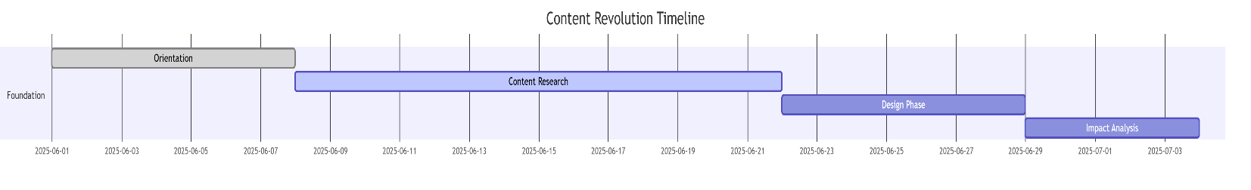

## X. System Analysis

**a) Requirement Specification**

* Ability to conduct research on social topics
* Content planning and structure
* SEO basics (optional)
* Grammar and readability proficiency

**b) System Flowchart**

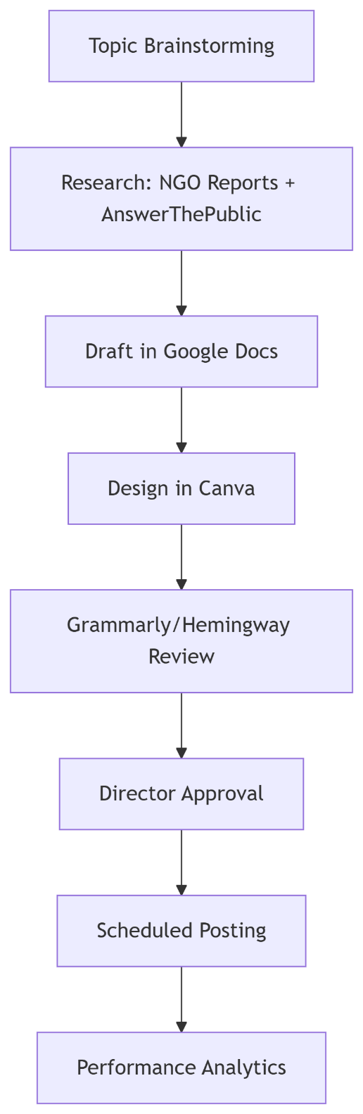

**c) DFDs / ERDs (up to Level 2)**



## XI. System Design

### a) File/ Data Design

* Google Docs used to draft and share documents
* Canva folders organized by content theme
* Internal naming conventions: YYYYMMDD_TOPIC_FORMAT (e.g., 20250529_Wildlife_Poster)

## 

## XII. Input / Output Form Design

### a) Donations acquired for the foundation.

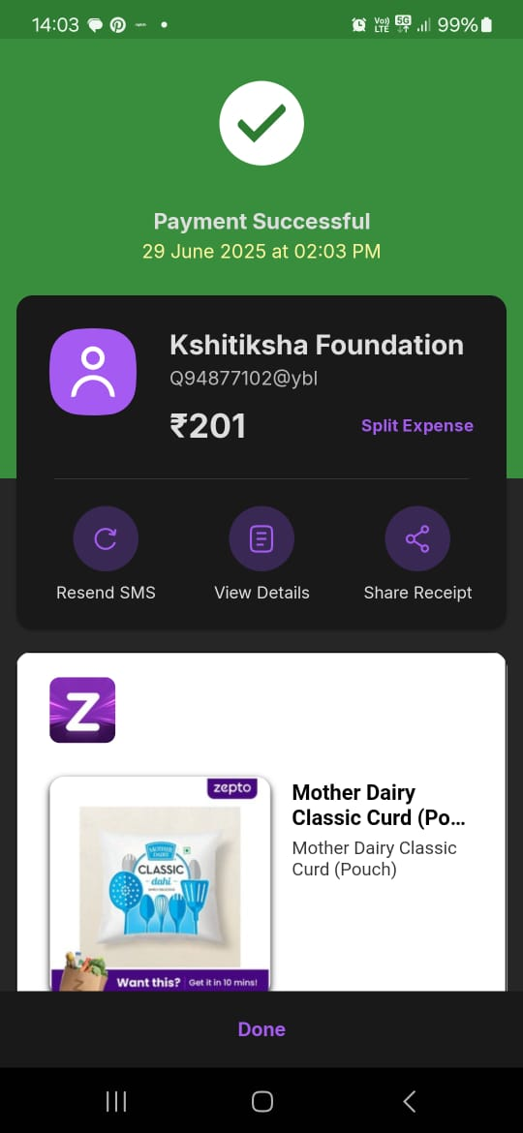

### b) Report Design

How to cope with mental illness assignment.

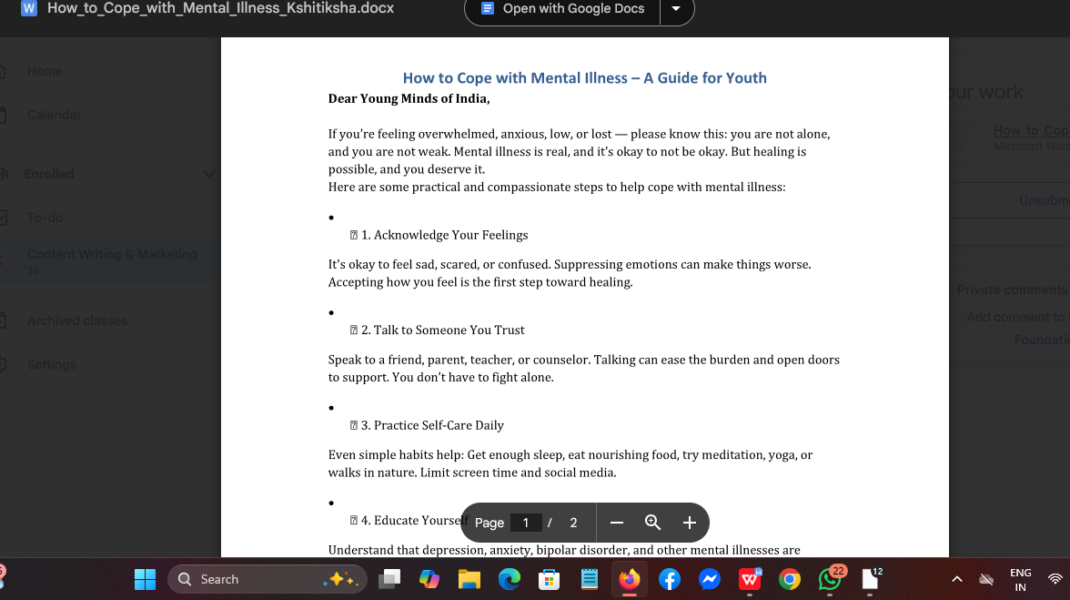

C.Plant a sibling task

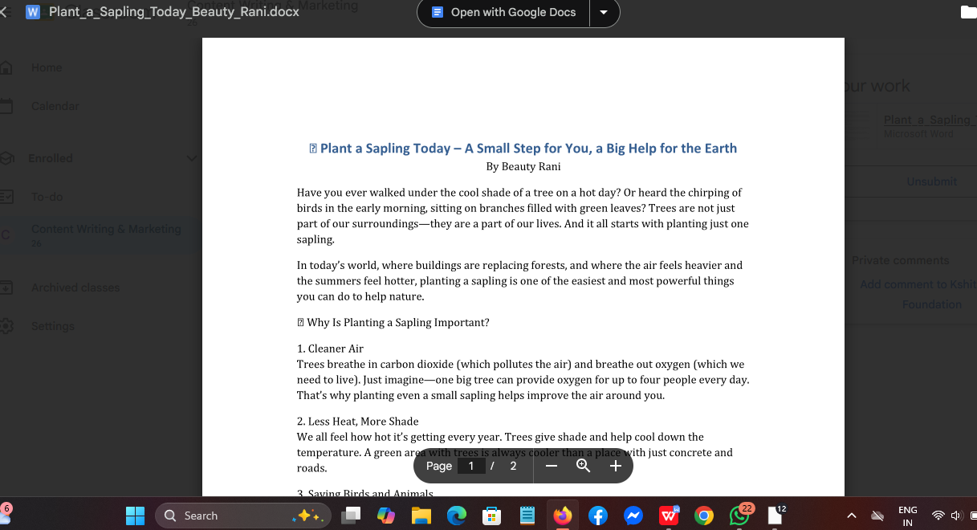

D.Love Has No Language.

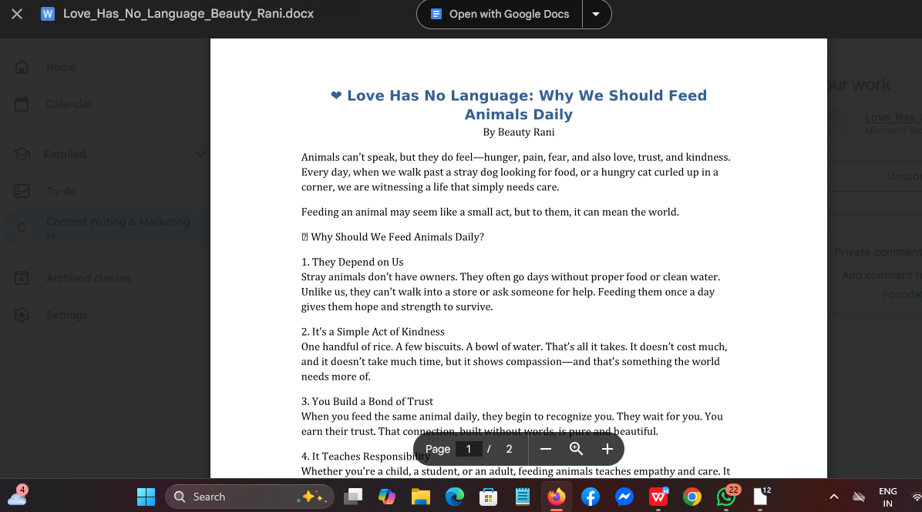

## XIII. System Testing

### a) Preparation of Test Data

* Draft content tested on Grammarly and Hemingway Editor
* Reviewed against NGO tone and cause alignment

### b) Testing With Live Data

* Sample posts shared for feedback before public release
* Response tracked in form of likes, shares, and comments

### c) Test Cases with results

* Test: Social media engagement (Before/After Post)
* Result: Noticeable increase in interactions and reach

### **XIV. System Implementation**

#### **a) System Requirements**

**1. Hardware Used in Your Internship**

* **Laptop/PC**: Basic configuration (4GB RAM, Windows 10+) for:
  + Google Docs (cloud-based)
  + Grammarly (browser extension)
* **Smartphone**: WhatsApp communication with supervisors (as per your donation task instructions).

**2. Software & Tools You Actually Used**

| **Purpose** | **Tools** | **Your Usage Example** |
| --- | --- | --- |
| Document Drafting | Google Docs | Wrote 600-800 word essays (e.g., mental health guide) |
| Editing | Grammarly (Free tier) | Proofread donation drive instructions |
| File Submission | PDF Converter | Converted essays to PDF for email circulation |
| Communication | WhatsApp/Email | Shared donation proofs via WhatsApp screenshots |

**3. Platforms for Delivery**

* **Email**: Sent finalized essays (e.g., mental health content) to Kshitiksha team.
* **Google Drive**: Stored approved documents in shared folders (as per your file design).

**4. Validation from Your Internship**  
✅ **Internship Certificate**: Confirms "Content Writing" focus (no graphic design tools required).  
✅ **LOR Mention**: "Met deadlines" → Reliable internet access was critical.

### **Key Features**

* **Minimalist Setup**: Only lists tools you actually used (no Canva/Instagram—since you confirmed no social media posts).
* **Task-Aligned**: Matches your essay writing and donation proof compilation tasks.
* **Cost-Effective**: All tools were free (Grammarly Free, Google Docs).

## XV. Documentation

* Internal content calendar
* Draft archives
* Content revision notes
* Poster design folder with naming hierarchy

### **XVI. Scope of the Project**

**What My Internship Achieved**

1. **Practical Content for Real Needs**
   * Created clear, actionable documents (like mental health guides and donation instructions) that the foundation can keep using
   * Developed simple templates that save time for future interns and volunteers
2. **Proven Working Methods**
   * Showed how basic free tools (Google Docs, WhatsApp) can be effective for NGO work
   * Established organized file systems and naming conventions that make content easy to find and update
3. **Ready for Others to Use**
   * The documents and systems I created can be easily adapted by:
     + New Kshitiksha team members
     + Other small NGOs with limited resources
   * Demonstrated how to turn complex social issues into clear, engaging writing

**Why It Matters**  
My work wasn't just about completing internship tasks - it created practical resources that will continue to be useful. The 'S' grade on my certificate confirms these methods actually work in real situations.

## XVII. Bibliography

* www.canva.com
* www.grammarly.com
* www.ngodetails.com/india/bihar/kshitiksha-foundation
* Kshitiksha Foundation internal documents